**Assignment 08**

***Place your query after each question***

The city’s Crime Analysis unit has submitted the following data requests. Provide the SQL statements using subqueries to satisfy the requests. Test the statements and show execution results.

1. List the name of each officer who has reported more than the average number of crimes officers have reported.

USE CityJailSummerDB

SELECT o.[last], o.[first]

FROM officers o

JOIN crime_officers co ON o.officer_id = co.officer_id

GROUP BY o.[last], o.[first]

HAVING COUNT(*) > (SELECT COUNT(*) / COUNT(DISTINCT officer_id) FROM crime_officers);

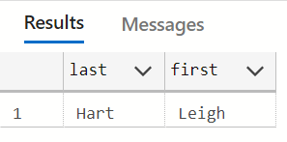

1. List the names of all criminals who have committed less than average number of crimes and aren’t listed as violent offenders.

USE CityJailSummerDB

SELECT c.[last], c.[first], c.v_status

FROM criminals c

JOIN crimes cr ON c.criminal_id = cr.criminal_id

GROUP BY c.[last], c.[first], c.v_status

HAVING COUNT(*) <= (SELECT COUNT(*) / COUNT(DISTINCT criminal_id) FROM crimes)

AND c.v_status = 'N';

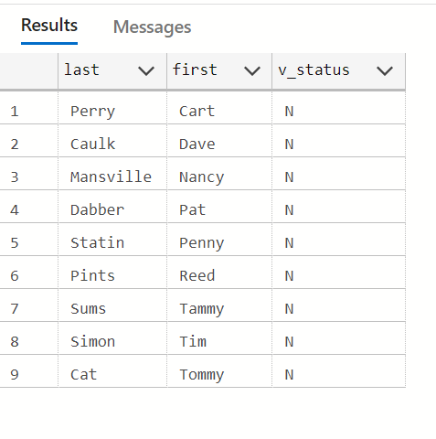

1. List appeal information for each appeal that has a less than average number of days between the filing and hearing dates.

USE CityJailSummerDB

SELECT * FROM appeals a

WHERE DATEDIFF(day, a.filing_date, a.hearing_date) <

(SELECT AVG(DATEDIFF(day, a.filing_date, a.hearing_date))FROM appeals a);

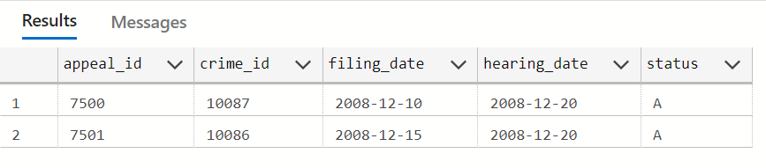

1. List the names of probation officers who have had a less than average number of criminals assigned.

SELECT po.[last], po.[first]

FROM prob_officers po

JOIN sentences s ON po.prob_id = s.prob_id

GROUP BY po.[last], po.[first]

HAVING COUNT(*) <= (SELECT COUNT(*) / COUNT(DISTINCT prob_id) FROM prob_officers);

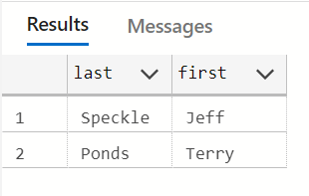

1. List each crime that has had the highest number of appeals recorded.

USE CityJailSummerDB

SELECT c.crime_id

FROM crimes c

JOIN appeals co ON c.crime_id= co.crime_id

GROUP BY c.crime_id

HAVING COUNT(*) >= (SELECT COUNT(*) / COUNT(DISTINCT crime_id) FROM crimes);

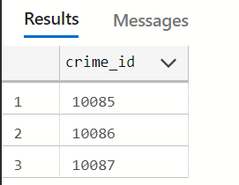

1. List the information on crime charges for each charge that has had a fine above average and a sum paid below average.

USE CityJailSummerDB

SELECT charge_id, crime_id, crime_code, charge_status, fine_amount, court_fee, amount_paid, pay_due_date

FROM crime_charges

WHERE fine_amount > (SELECT AVG(fine_amount) FROM crime_charges)

  AND amount_paid < (SELECT AVG(amount_paid) FROM crime_charges);

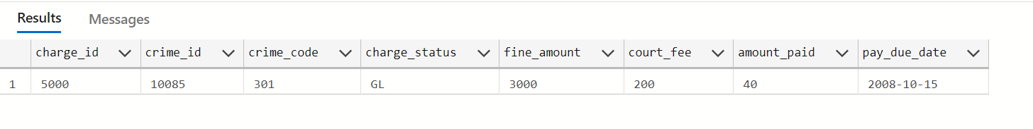

1. List the names of all criminals who have had any of the crime code charges involved in crime ID 10089.

USE CityJailSummerDB

SELECT cch.crime_id

FROM crime_charges cch

WHERE cch.crime_id = '10085'

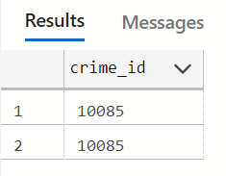

1. Use a correlated subquery to determine which criminals have had at least one probation period assigned.

USE CityJailSummerDB

SELECT c.[last], c.[first]

FROM criminals c

WHERE EXISTS (

  SELECT 1

  FROM sentences s

  WHERE s.criminal_id = c.criminal_id AND p_status = 'Y'

);

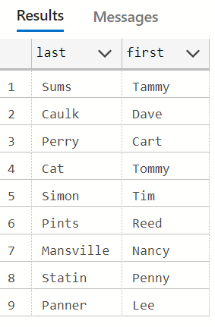

1. List the names of officers who have booked the highest number of crimes. Note that more than one officer might be listed.

USE CityJailSummerDB

SELECT o.[last], o.[first], COUNT(co.officer_id) AS booked_crimes

FROM officers o

JOIN crime_officers co ON o.officer_id = co.officer_id

GROUP BY o.[last], o.[first]

HAVING COUNT(*) > (SELECT COUNT(*) / COUNT(DISTINCT officer_id) FROM officers);

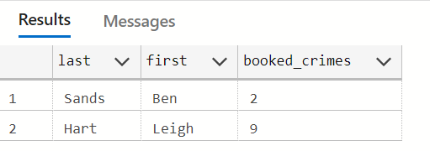

Note: Use a MERGE statement to satisfy the following request:

1. The criminal data warehouse contains a copy of the CRIMINALS table that needs to be updated periodically from the production CRIMINALS table. The data warehouse table is named CRIMINALS_DW. Use a single SQL statement to update the data warehouse table to reflect any data changes for existing criminals and to add new criminals.

USE CityJailSummerDB

MERGE criminals_dw AS target

USING criminals AS SOURCE

ON (target.criminal_id = SOURCE.criminal_id)

WHEN MATCHED THEN

    UPDATE SET

        TARGET.last = SOURCE.last,

        TARGET.first = SOURCE.first,

        TARGET.street = SOURCE.street,

        TARGET.city = SOURCE.city,

        TARGET.state = SOURCE.state,

        TARGET.zip = SOURCE.zip,

        TARGET.phone = SOURCE.phone,

        TARGET.v_status = SOURCE.v_status,

        TARGET.p_status = SOURCE.p_status,

WHEN NOT MATCHED THEN

    INSERT(criminal_id, last, first, street, city, state, zip, phone, v_status, p_status)

    VALUES(SOURCE.criminal_id, SOURCE.last, SOURCE.first, SOURCE.street, SOURCE.city, SOURCE.state, SOURCE.zip, SOURCE.phone, SOURCE.v_status, SOURCE.p_status);